Matching Maternity Demand & Resources

General Practitioners Assistance Requested

As a provider of tertiary level care to women and babies, Mercy Hospital for Women has a commitment to ensure quality services are maintained in the face of extraordinary demand. Victorian government strategies are being implemented to maintain services for all women in the right location. Thus it has become necessary to manage the number of women with low risk pregnancies utilising the specialist services at Mercy Hospital for Women and to encourage these women to utilize their local maternity services. To facilitate this, maternity booking criteria have been introduced which will change the booking process.

Maternity bookings at Mercy Hospital for Women will be accepted from women meeting one of the following criteria:

- Higher risk or complex pregnancy. Experienced midwives triage all referrals and potential bookings to ascertain pregnancy risk.
- Previous delivery at Mercy Hospital for Women and within accepted region.
- Normal place of residence in accepted geographical region as defined by postcode.
In general, this comprises the north-east metropolitan area and north-east regional Victoria, excluding places in closer proximity to TNH, RWH or Box Hill.

Mercy Hospital for Women region
Postcodes 3070 – 3115 (North – East Metropolitan)
EXCEPT Thomastown (3074), Lalor (3075), Epping (3076) & Mill Park (3082) – appropriately directed to The Northern Hospital
Postcodes 3700 – 3799 (North – East Regional)

Women residing outside region
Women who reside outside the Mercy Hospital for Women catchment area and are triaged as a low risk pregnancy will be recommended to seek maternity care at an alternative local health service such as The Northern Hospital. Transfers for women with threatened pre-term labour will still be possible with fetal fibronectin testing assisting in determining if labour is imminent.

Management of redirected referrals from GPs

- GP referrals received by fax or phone will be triaged. Experienced midwives will contact these women by telephone (hence the importance of accurate phone contact details) and those who are assessed as having a low risk pregnancy will be redirected to a maternity services provider in their local area.
- The referring GP will be notified by fax.
- Any copies of the referral letter and investigations received will be posted to each woman to enhance her continuity of care
- GPs will be notified if contact is unable to be made with a woman out of region, as the referral cannot be triaged.

GP assistance is requested to ensure each women is appropriately booked and that results of any investigations are forwarded to the relevant hospital.

GP enquiries
GPs wishing to discuss individual patient management may telephone the Medical Head of Unit in antenatal clinic between 9am – 12noon weekdays via switchboard on 8458 4444.

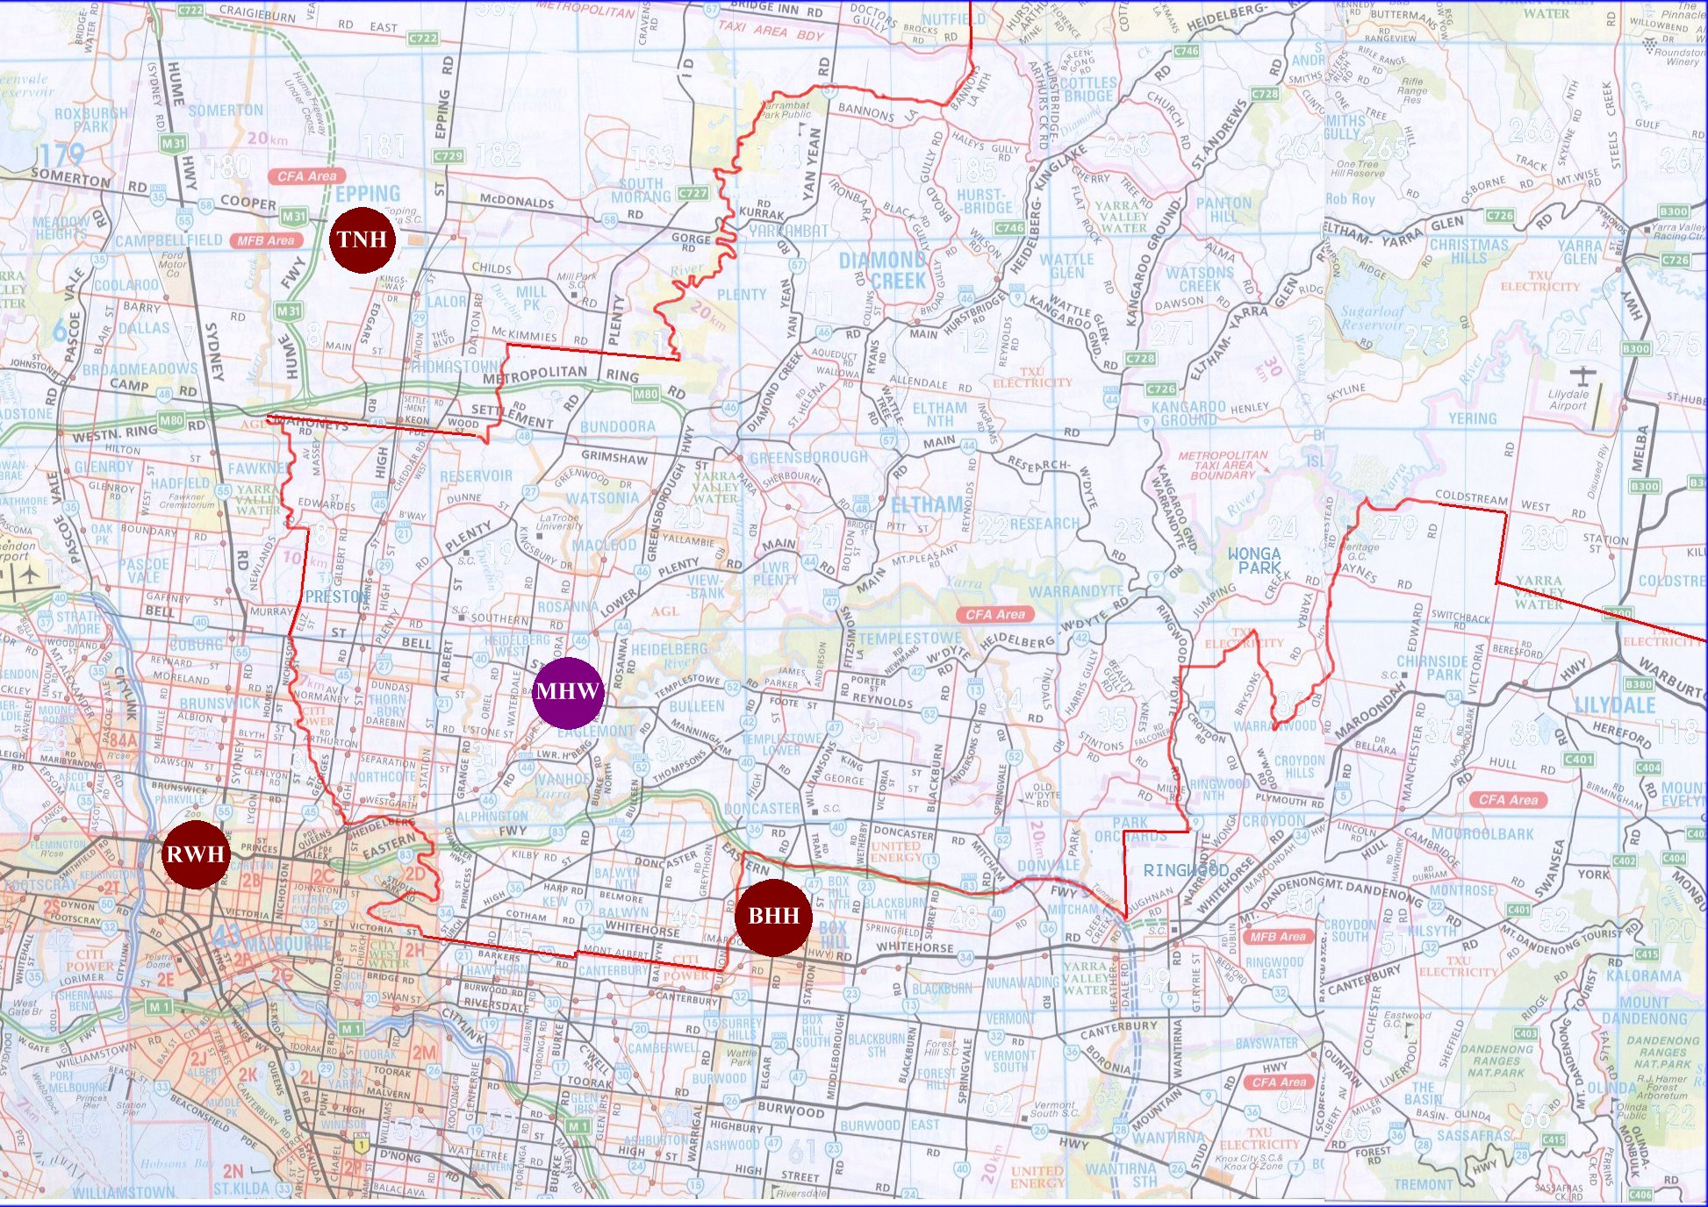
POSTCODE GUIDE

Mercy Hospital for Women region comprises:
Postcodes 3070 – 3115 (North – East Metropolitan)
EXCEPT Thomastown (3074), Lalor (3075), Epping (3076) & Mill Park (3082) – appropriately directed to The Northern Hospital
Postcodes 3700 – 3799 (North – East Regional)

Postcode Guide for Telephone Triage

Pregnancy bookings accepted at Mercy Hospital for Women

Postcodes 3070 – 3115 (North-East Metropolitan)
      - Accepted to Mercy Hospital for Women
EXCEPT Thomastown (3074), Lalor (3075), Epping (3076), Mill Park (3082)
      - Appropriately directed to TNH

Postcodes 3700 – 3799 (North-East Regional)
      - Accepted to Mercy Hospital for Women (although may advise nearer regional centre)

Pregnancy booking request appropriately directed

Postcodes 3000 – 3068 (Central, North, West and South-West Metropolitan)
      - Appropriately directed to their nearest metropolitan maternity hospital
      - Maternity hospitals in those districts include:
The Northern Hospital (TNH), Royal Women’s Hospital (RWH), Western (W), Werribee Mercy Hospital (WMH)

Postcodes 3116 – 3199 (East, South-East and South Metropolitan)
      - Appropriately directed to their nearest metropolitan maternity hospital
      - Maternity hospitals in those districts include:
Box Hill, Ferntree Gully (William Angliss), Monash, Sandringham, Dandenong, Frankston

Postcodes 3200 – 3699 (South-West, West, North-West and North Regional)
      - Appropriately directed to their nearest regional or metropolitan maternity hospital

Postcodes 3800 – 3999 (East, South-East & South Regional)
      - Appropriately directed to their nearest regional or metropolitan maternity hospital

